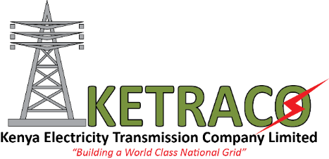
For immediate release:
DREAM OF AFFORDABLE ELECTRICITY FOR KENYANS BECOMING A REALITY.
Nairobi, 28th October 2015
The Kenya Electricity Transmission Company Limited (KETRACO) today signed a USD 230M contract with Siemens AG-Isolux Inginieria Consortium for the construction of the Suswa High Voltage Direct Current Converter substation, a component of the Ethiopia – Kenya interconnector.
Upon its completion, the project shall ensure affordable access to electricity by Kenyans, industries and the local governments due to the cheap hydropower from Ethiopia. The Interconnection will also offer alternate power supply to Kenya and Ethiopia in the dry season when hydro generation is dismal.
The proposed bipolar 500 kV HVDC line will originate from Wolyata Sodo in Ethiopia and terminate in Suswa, Kenya. Suswa is a critical hub that will serve as an entry and exchange point for power into the national grid and facilitate power trade in the Eastern Africa Power Pool. The total length of the project is 1045Km, out of which 433km will be in Ethiopia and the remaining 612km in Kenya.
Speaking during the ceremony, KETRACO Acting Managing Director FCPA Fernandes Barasa noted that with a transmission capacity is 2,000 MW in either direction, the project will facilitate power trade in the East Africa Power Pool.
The transmission line contracts are funded through loans from the African Development Bank (AfDB) and The French Development Agency (AFD) while the HVDC Converter substation is funded through the World Bank.
The 612km transmission line in Kenya has been broken into Lots 4, 5 and 6 whose tenders were respectively awarded to KEC International Ltd-India, Larsen and Toubro Limited Power Transmission and Distribution and Kalpataru Power Transmission Ltd, India at a total cost of USD 140 Million.
The transmission line contractors are already mobilised and they are expected to complete construction in December 2017, while the HVDC Converter substation is expected to take 36 months and therefore be commissioned at about October 2018.
The Kenya Power and Lighting Company already has a power purchase agreement with Ethiopia Electric Power Company for a supply of 400 MW. This amount of supply will increase as demand and supply increases over time.

The Eastern Electricity Highway Project is part of a program to integrate the Eastern African region by supporting the integration of power systems of the countries with a combined population of over 200 million. Within the framework of the East Africa Power Pool (EAPP), the Program has three phases for connecting the power grids of Ethiopia, Kenya, Tanzania, Uganda, Burundi and Rwanda. The EAPP’s Master Plan, endorsed by the governments of the member countries, has designated the transmission interconnections among these countries as priorities for the development of the Eastern Africa power market. These interconnections will create the transmission backbone for the region. Kenya is expected to become the central node of the integrated system. Also, once the planned Tanzania-Zambia interconnection is constructed, the EAPP power systems will be linked to the Southern African Power Pool.

For more information contact:

Raphael Mworia
Manager Corporate Communications
KETRACO
0702-949951/020-4956750
rmworia@ketraco.co.ke
www.ketraco.co.ke

